Full Stack Development with MERN
Project Documentation format
1. Introduction
• Project Title: FlightFinder- Navigating Your Air Travel Options
• Team Members:

Name | Role
Bittu Nagaprasanth | Team Leader & Full Stack Developer
Dharmana Kiran Sai | Frontend Developer (React.js, UI Design)
Burla Harish Rao | Backend Developer (Node.js, Express.js)
Boggavarapu Praveen Kumar | Database Developer (MongoDB Atlas)

2. Project Overview
• Purpose: The purpose of this project is to develop a Flight Booking Web Application that allows users to search and book flights easily. The system helps travelers find suitable flights based on their preferences.
The application is developed using the MERN Stack (MongoDB Atlas, Express.js, React.js, Node.js).
Features:
- Flight Search
- Flight Details Display
- Flight Booking
- User-Friendly Interface
- MongoDB Atlas Database Storage
- Responsive Design
- Fast Search Results
3. Architecture
• Frontend:
The frontend is developed using React.js and provides an interactive user interface.
Features:
- Flight Search Form
- Booking Form
- Flight Results Display
- Responsive UI
Technologies Used:
- React.js
- HTML
- CSS
- Bootstrap
- JavaScript

• Backend: The backend is developed using Node.js and Express.js
Functions:
- Handles user requests
- Processes flight search
- Stores booking data
- Connects to MongoDB Atlas
Technologies Used:
- Node.js
- Express.js
.
4. Setup Instructions
• Prerequisites: List software dependencies (e.g., Node.js, MongoDB).
• Installation: Step-by-step guide to clone, install dependencies, and set up the environment variables.
5. Folder Structure
• Client: Describe the structure of the React frontend.
• Server: Explain the organization of the Node.js backend.
6. Running the Application
• Provide commands to start the frontend and backend servers locally. o Frontend: npm start in the client directory.
o Backend: npm start in the server directory.
7. API Documentation
Get Flights
Endpoint
GET /api/flights
Description
Returns all flight details.
Example Response
{
"flight":"Indigo",
"source":"Hyderabad",
"destination":"Chennai",
"price":4500
}

Book Flight
Endpoint
POST /api/bookings
Description
Stores booking details.
Example Request
{
"name":"Prasanth",
"email":"test@gmail.com",
"source":"Hyderabad",
"destination":"Chennai"
}
9. User Interface
• Provide screenshots or GIFs showcasing different UI features.
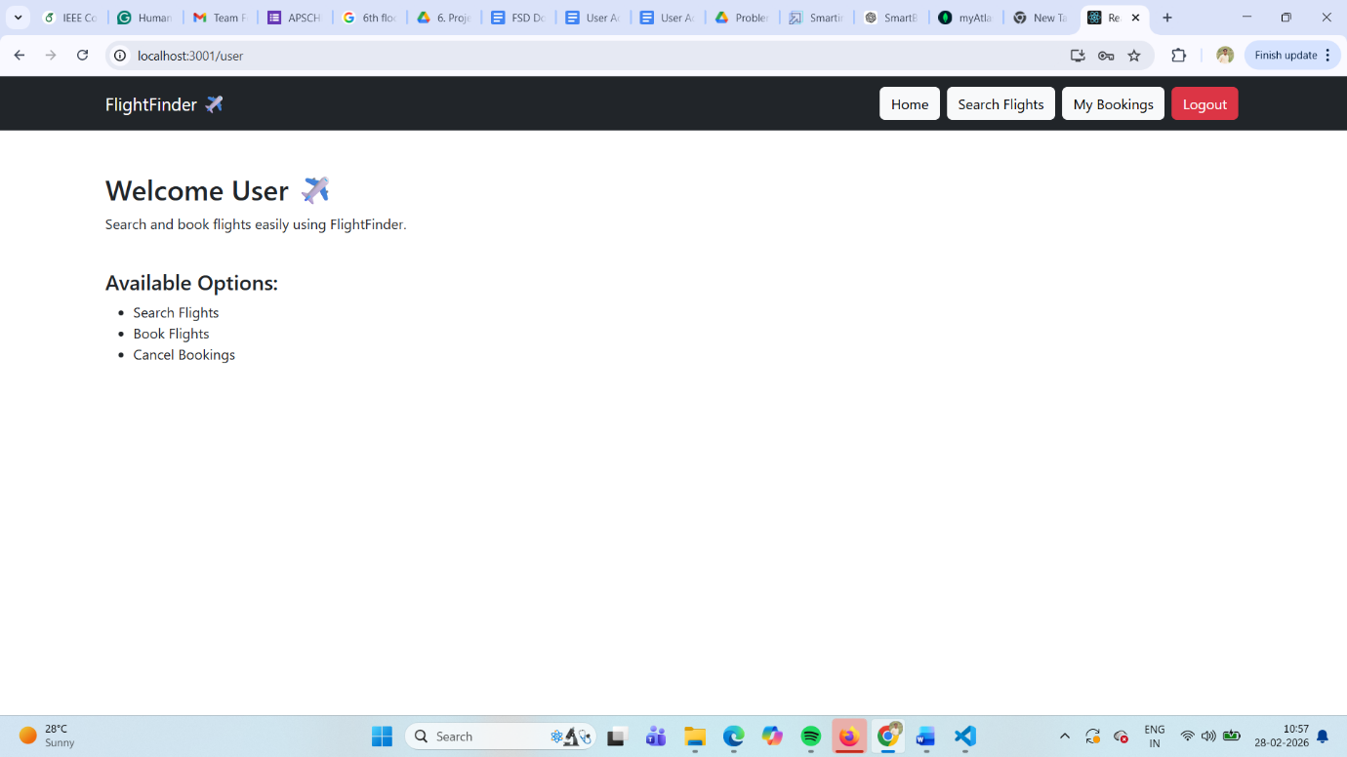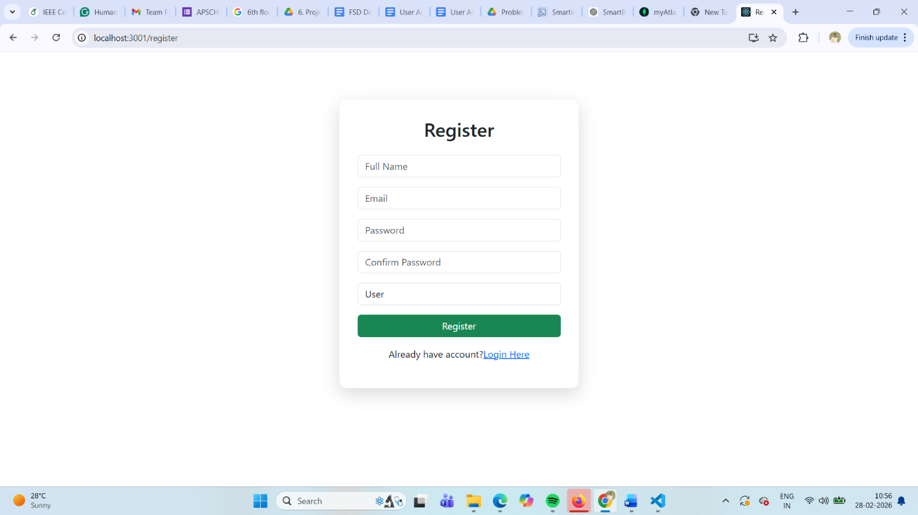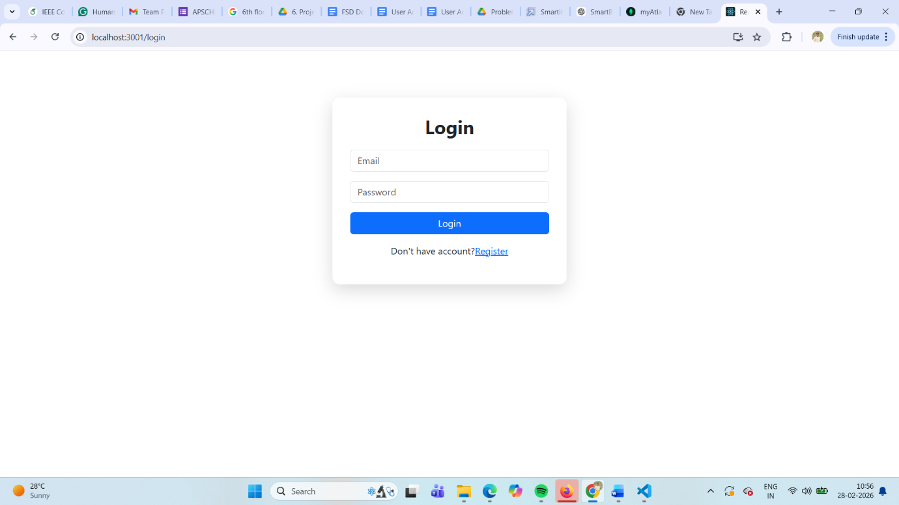
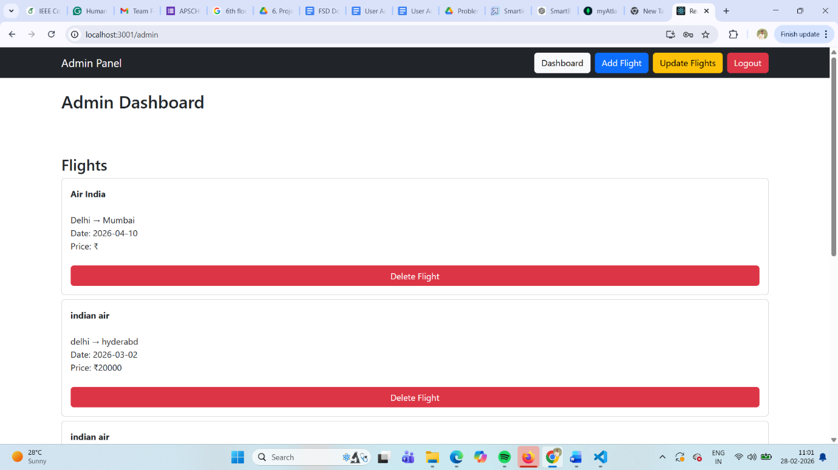
10. Testing
Testing Strategy
Manual testing was used to verify system functionality.
Testing includes:
- Flight Search Testing
- Booking Testing
- Database Testing
- Input Validation Testing
Tools Used
- Web Browser Testing
- MongoDB Atlas Testing

11. Screenshots or Demo
• Provide screenshots or a link to a demo to showcase the application.

